1. Homepage:Below the web site: Click on 4dl Bangladesh (we don’t find this website)

2. Elite club er design e click korle homepage thkse na log out hoy jase..

3.User login er pore profile name click korle Wall e jano thke.Ex :**imo miya** click korle **imo miya** wall e thke.

4.Search menu kaj kora hoy nai

5.**Architectural Archive (Interior Work):**does’t work properly...pic upload kora jase na

6. Single pic singe status upload hoy but Aksathe photo + Status upload kora jai na

<http://localhost:8085/interior-work.html>

<http://localhost:8085/exterior-work.html>

<http://localhost:8085/special-work.html>

<http://localhost:8085/landscape-work.html>

7.status+ Attached file aksathe post kora jase na.

.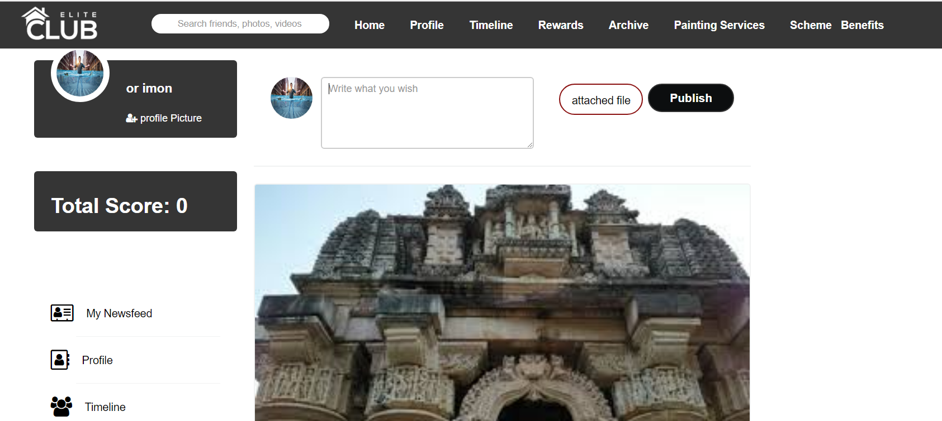

### Upload photo korle status photo neche asce..Photo er Upore hole valo hoy.

8. Like & Unlike kora jai na.

9. Timeline ->Featured Skills : name similar column dete hobe

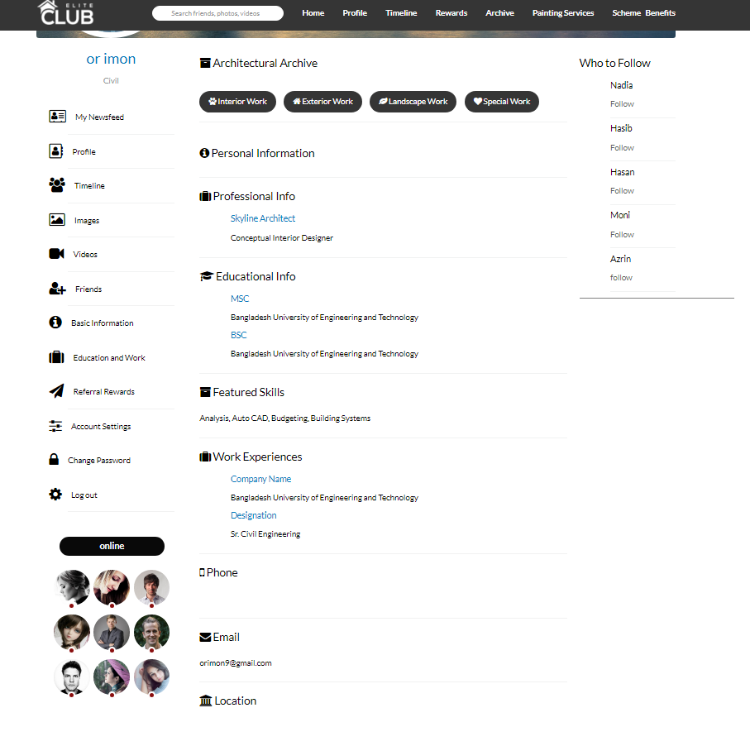

10.Rewards ->Project Reference Point Awarded send hoi na

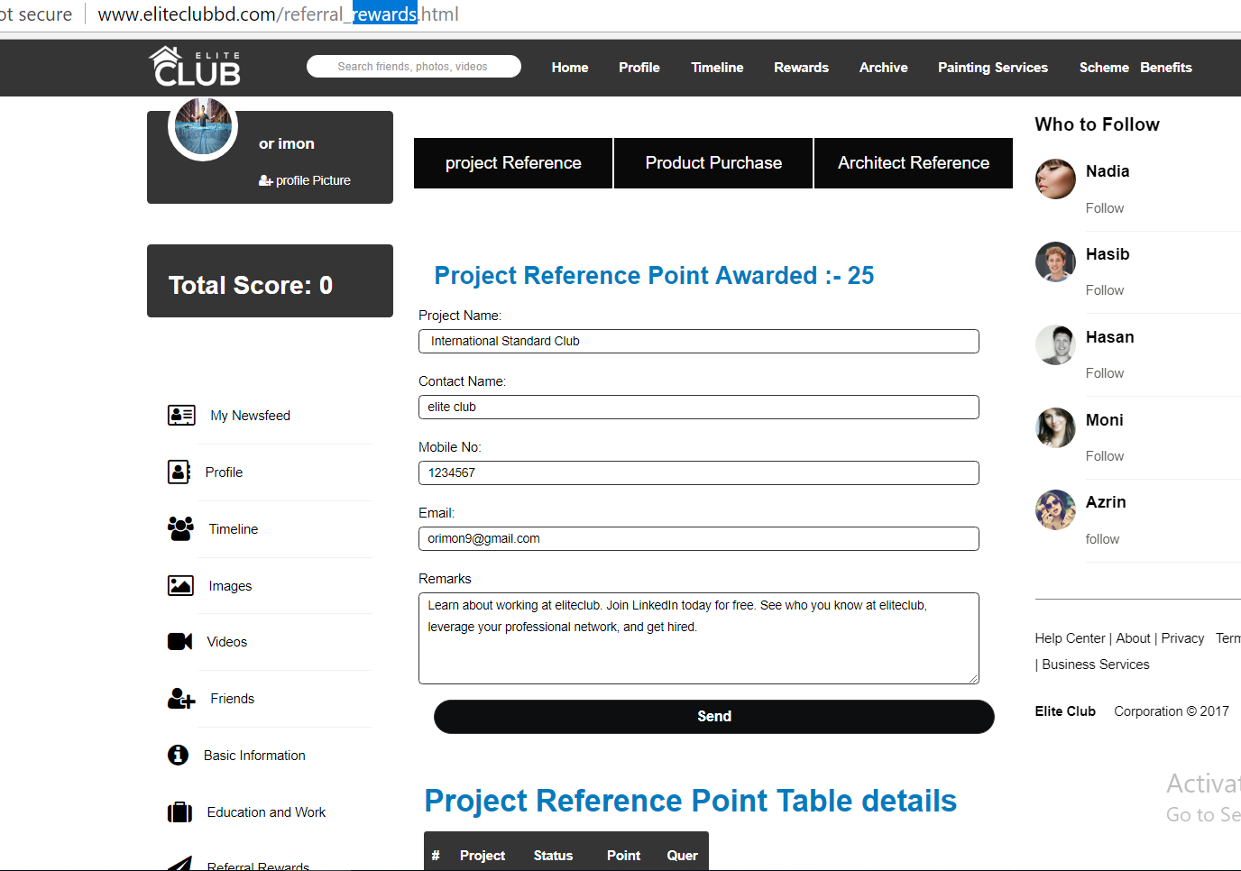

10.Rewards ->Product Purchase Point Awarded send hoi na

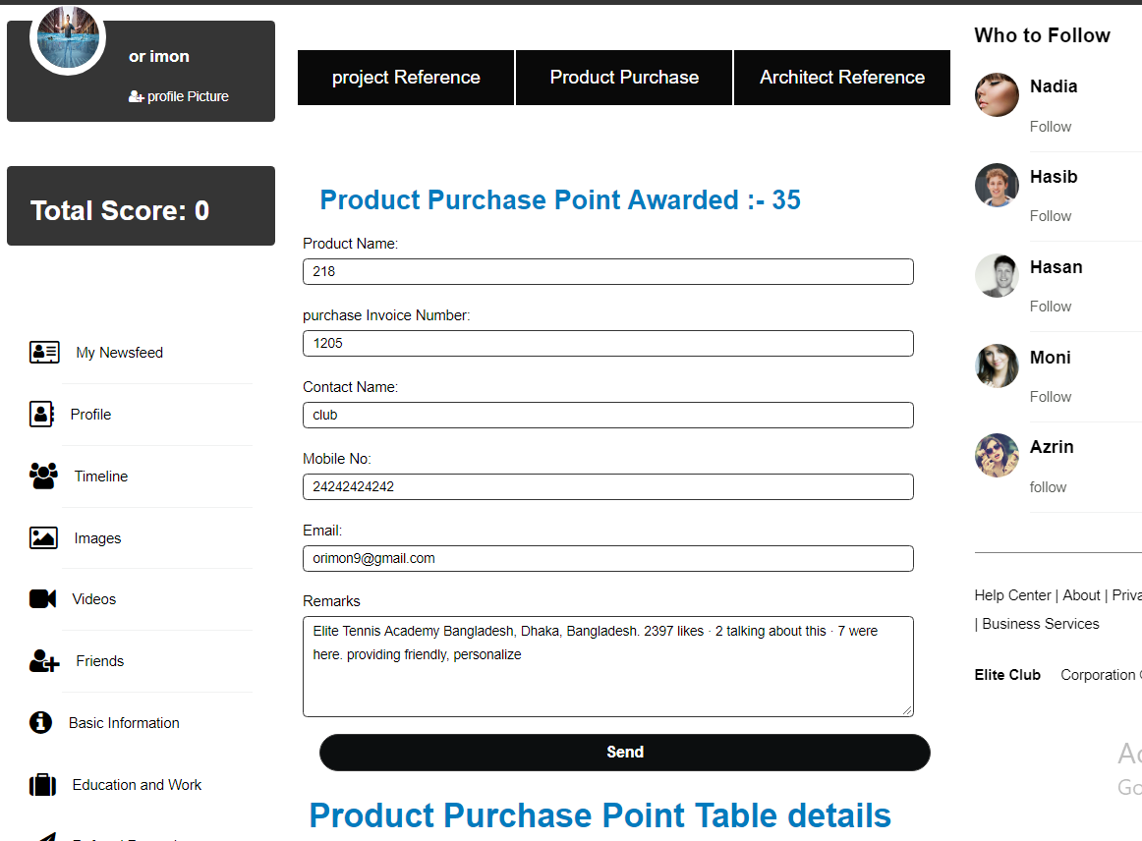

11.**Project Reference Point Table details ….Table kothay??**

**http://www.eliteclubbd.com/referral_rewards.html**

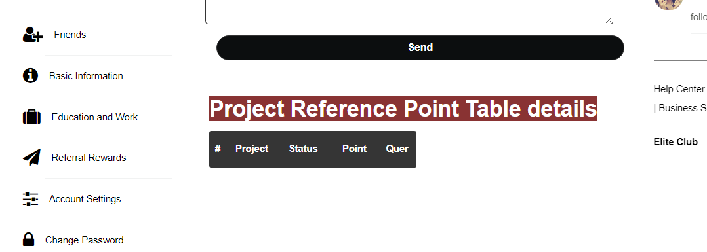

12.Archive-> <http://www.eliteclubbd.com/referral_rewards.html>

Status Photo er upore hole valo hoi

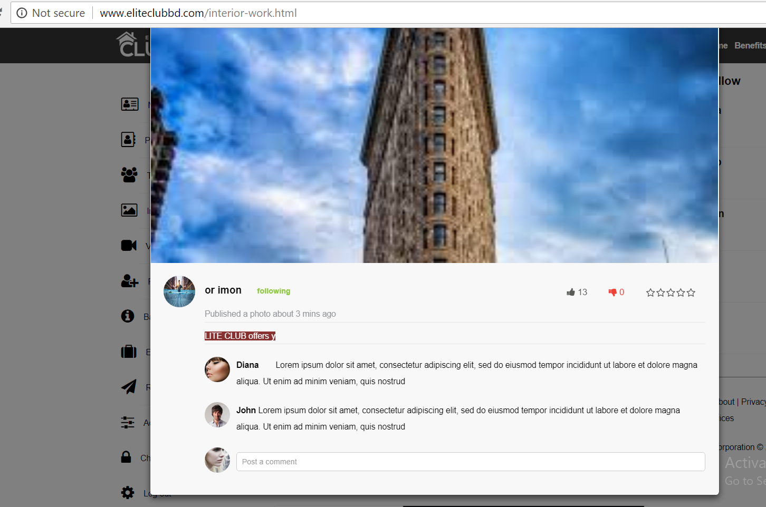

13.**Painting Services->Price Quotation:Submit hoi na.**

[**http://www.eliteclubbd.com/painting_service.html**](http://www.eliteclubbd.com/painting_service.html)

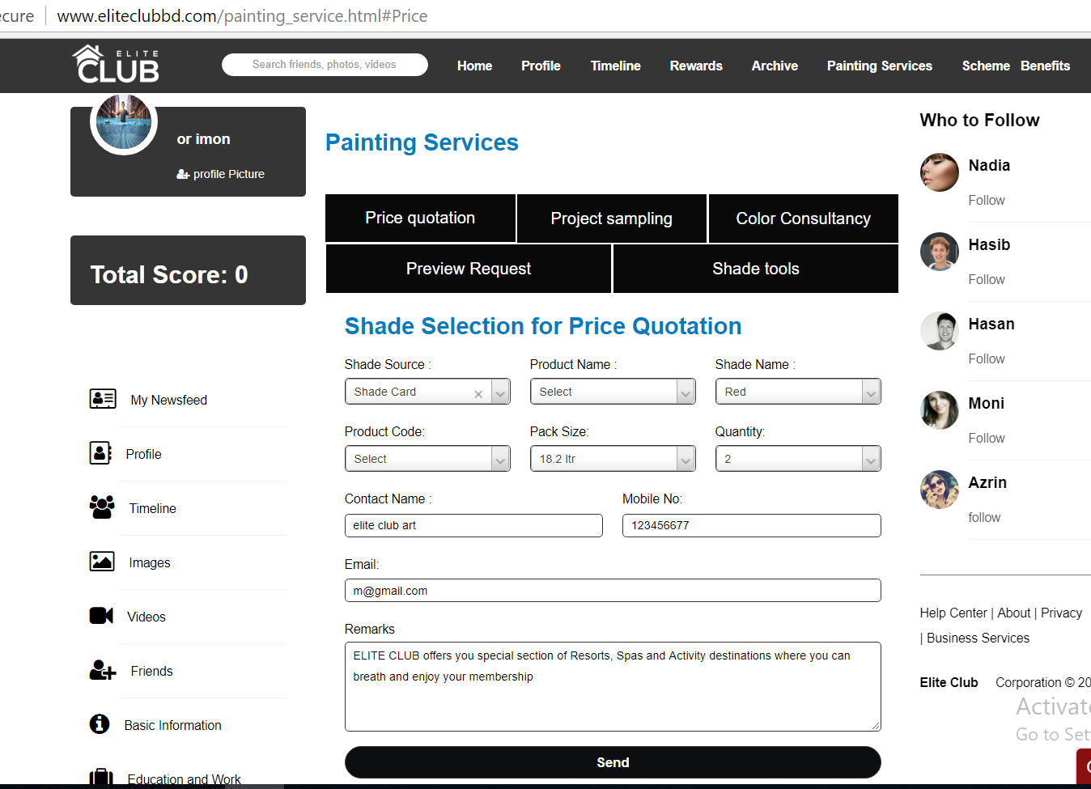

**14.**Project Sampling->send hoi na.

<http://www.eliteclubbd.com/painting_service.html#Projectsampling>

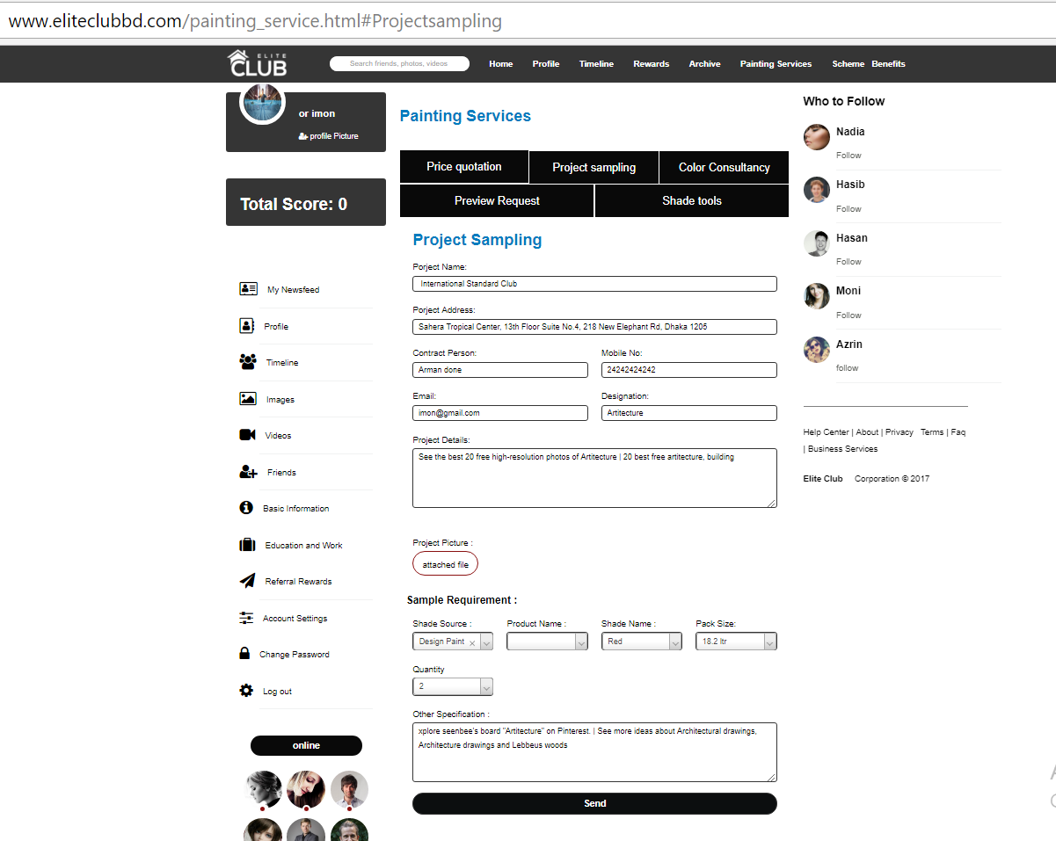

15.**Painting Services->Color Consultancy->Image ba vedio dele homepage chole jai &&& send hoise na??**



16.Project Preview Request-> submit hoi na & photo attached korle main page chole jai

<http://www.eliteclubbd.com/painting_service.html#Preview>

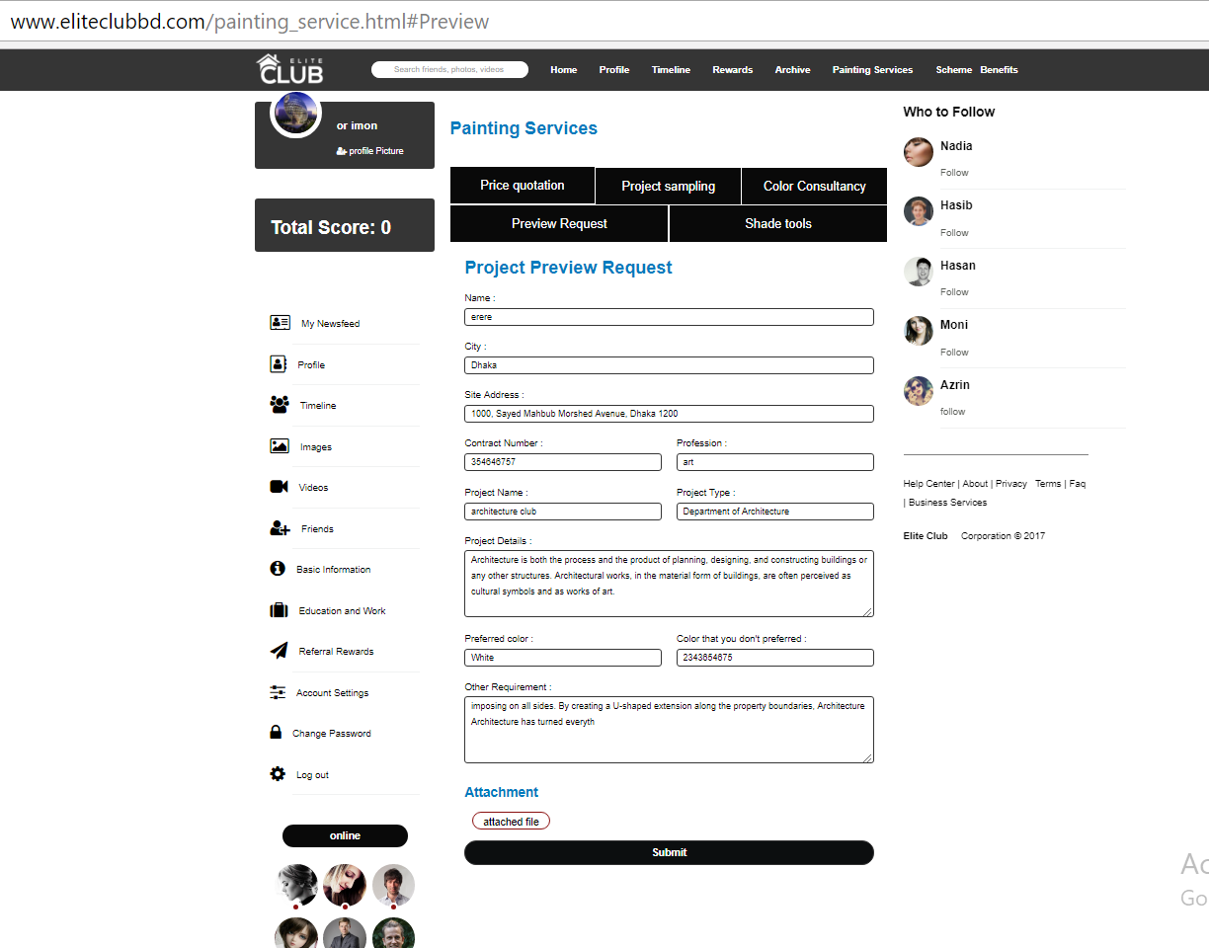

17.**Shade Tools->Shade Tools Required product:Save change hoi na**

[**http://www.eliteclubbd.com/painting_service.html#Shade**](http://www.eliteclubbd.com/painting_service.html#Shade)

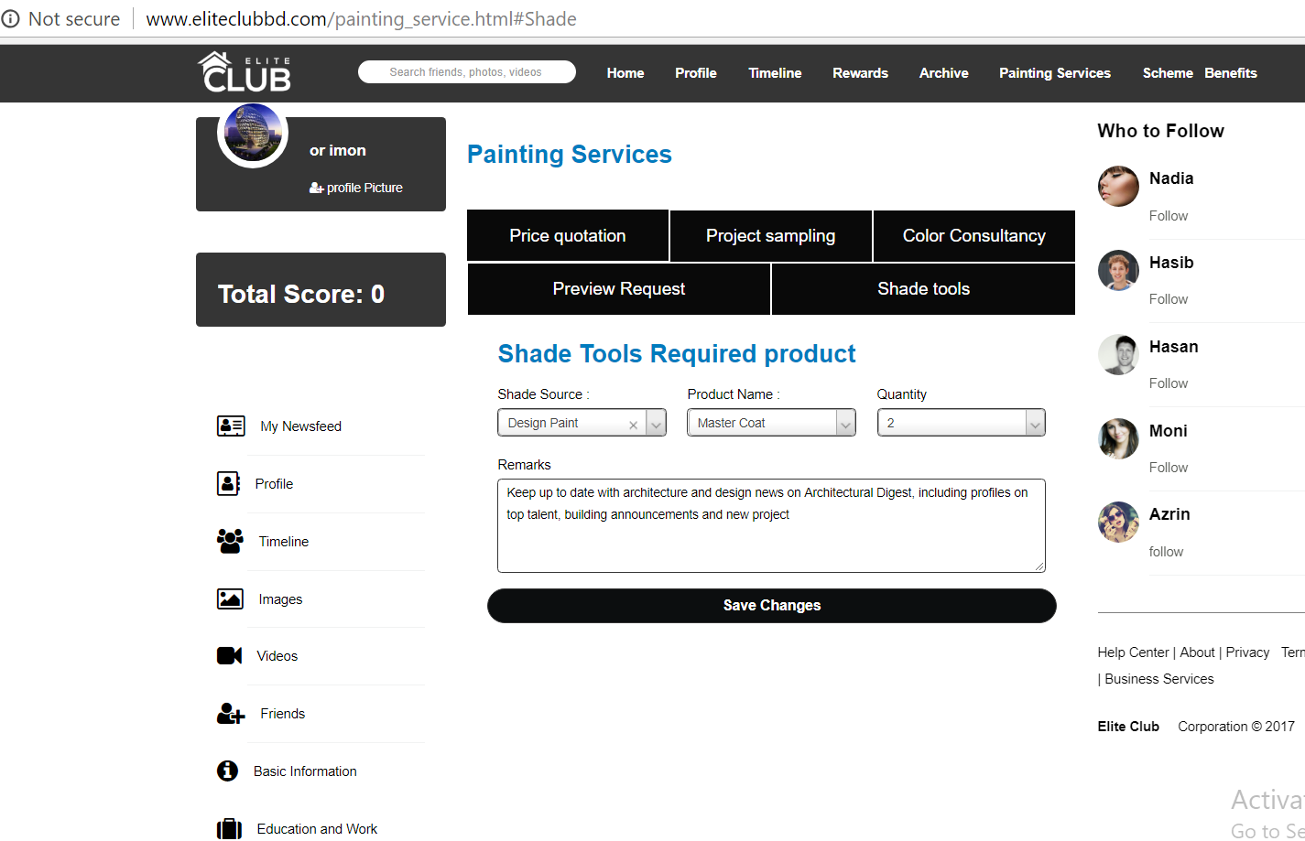

**18.Image,vedio upload ba status deia jai na???**

[**http://www.eliteclubbd.com/newsfeed-images.html**](http://www.eliteclubbd.com/newsfeed-images.html)

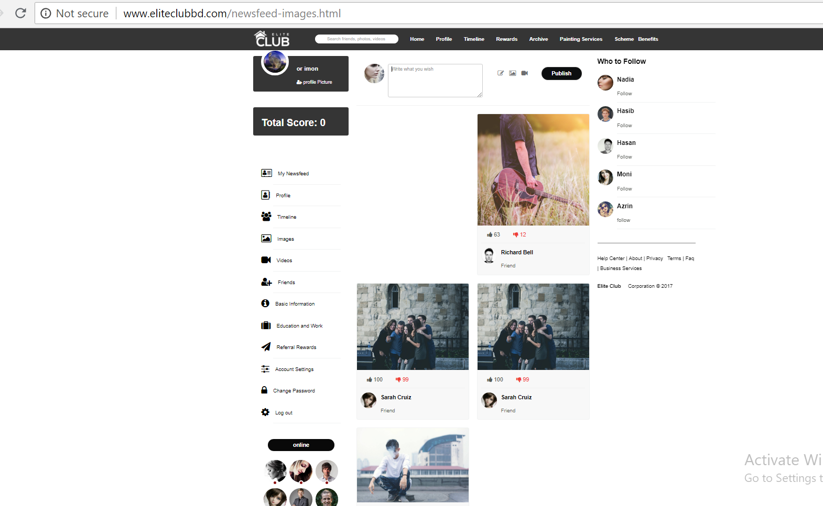

**18. Schema->Product Benifits: Correct spelling benefit, Size & point column er mid e hobe.**

[**http://www.eliteclubbd.com/Scheme-benefits.html**](http://www.eliteclubbd.com/Scheme-benefits.html)

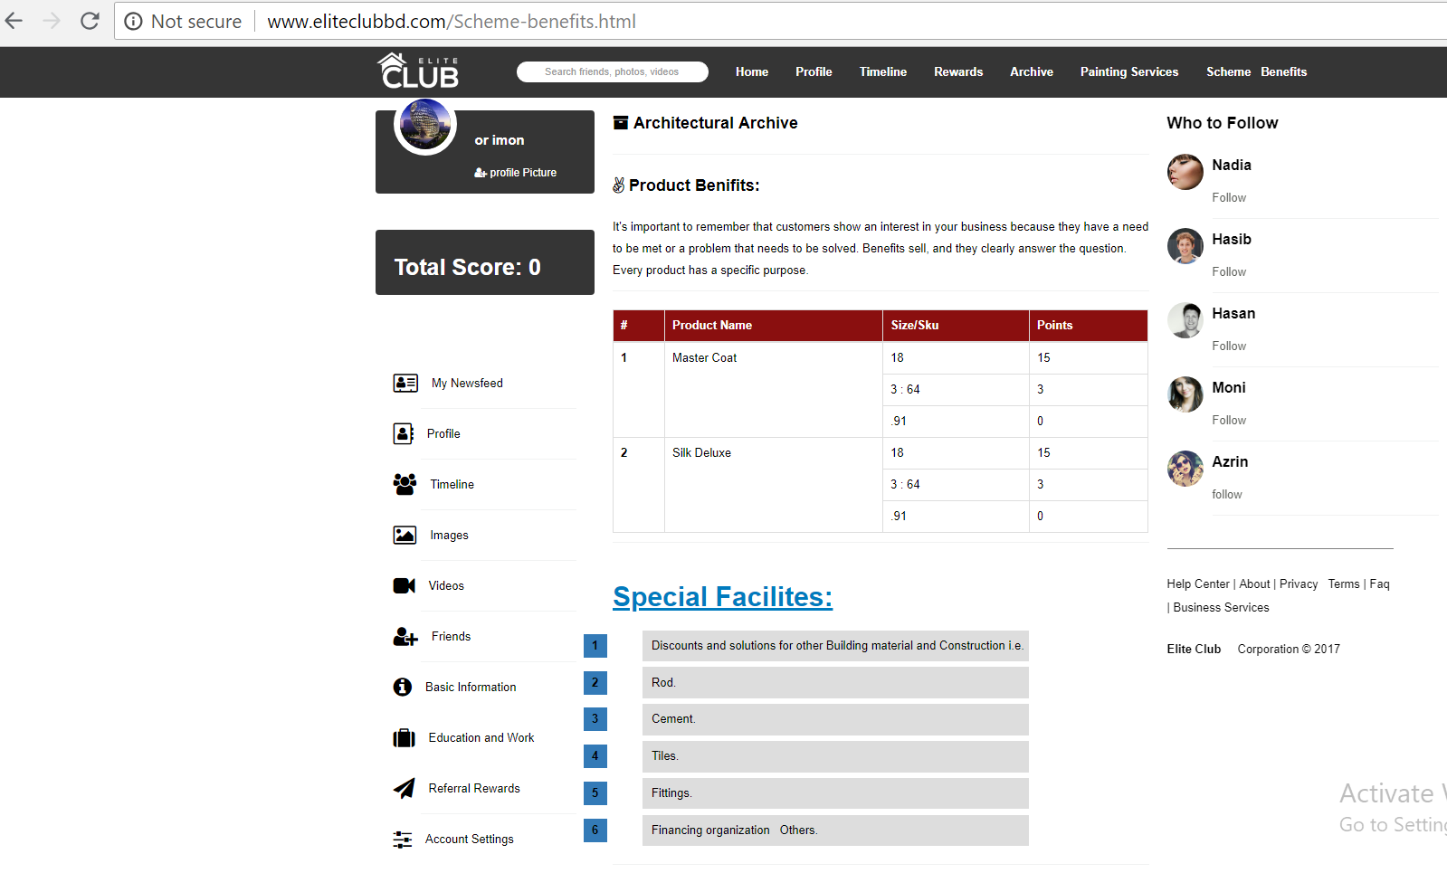

19.[Basic Information](http://www.eliteclubbd.com/user/edit-profile-basic.html)->Edit basic information -save change hoi successfully message deia na??

<http://www.eliteclubbd.com/user/edit-profile-basic.html>

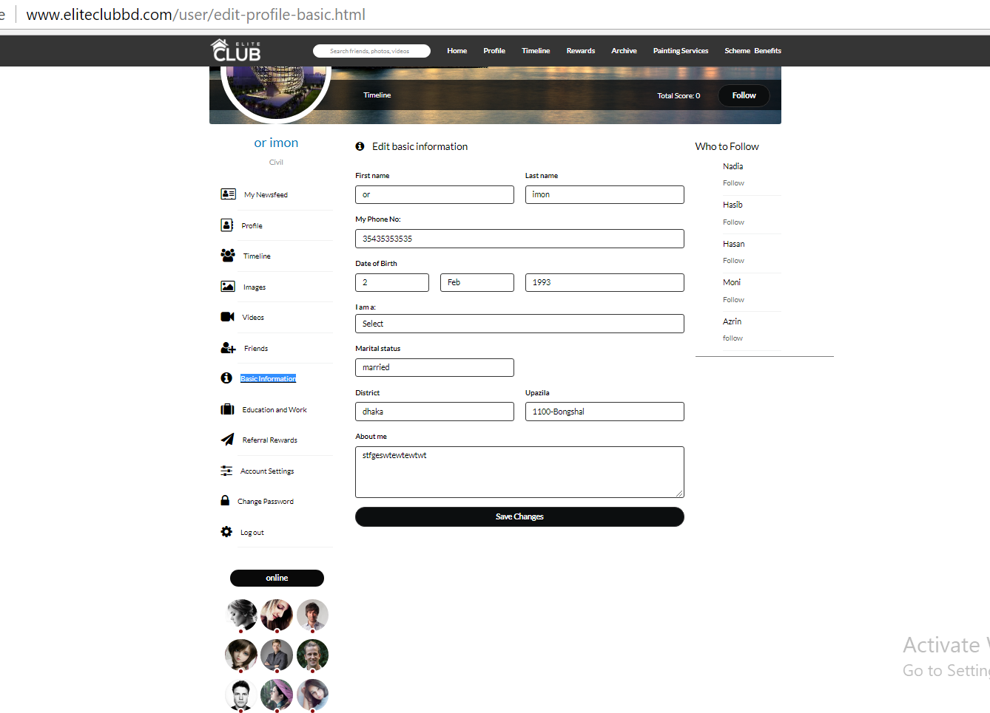

20. **My education from er input change korte hobe??S.S.C in & School Name:**

**Save change korle**  successfully message koi?

<http://www.eliteclubbd.com/edit-profile-work-edu.html>

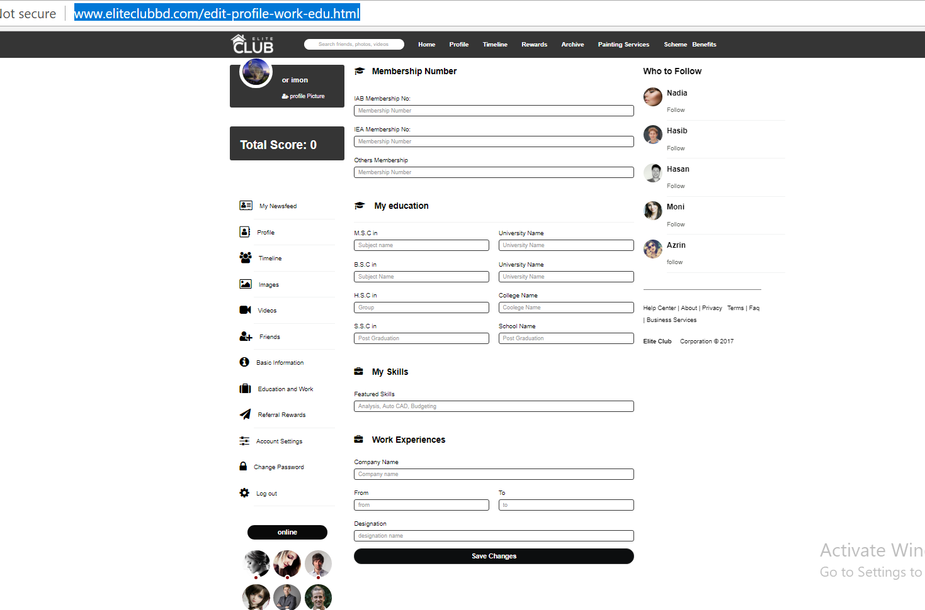

20. [Change Password](http://www.eliteclubbd.com/edit-profile-password.html): password change kora jai na.change korle error hoi….

<http://www.eliteclubbd.com/edit-profile-password.html>

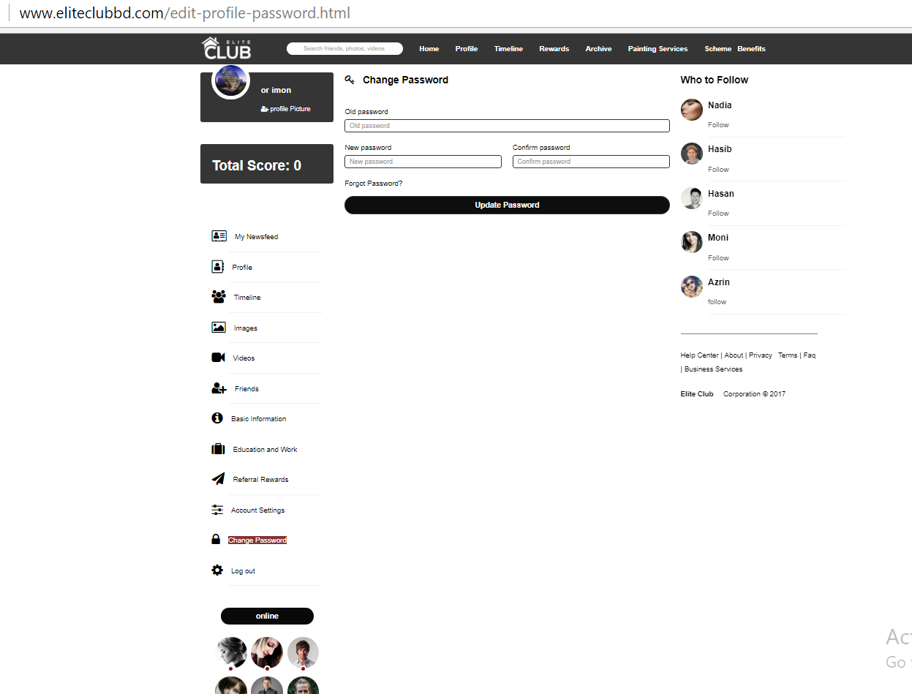

21. Forgot Password click kore old password change kora jai na ??

<http://www.eliteclubbd.com/index.html>

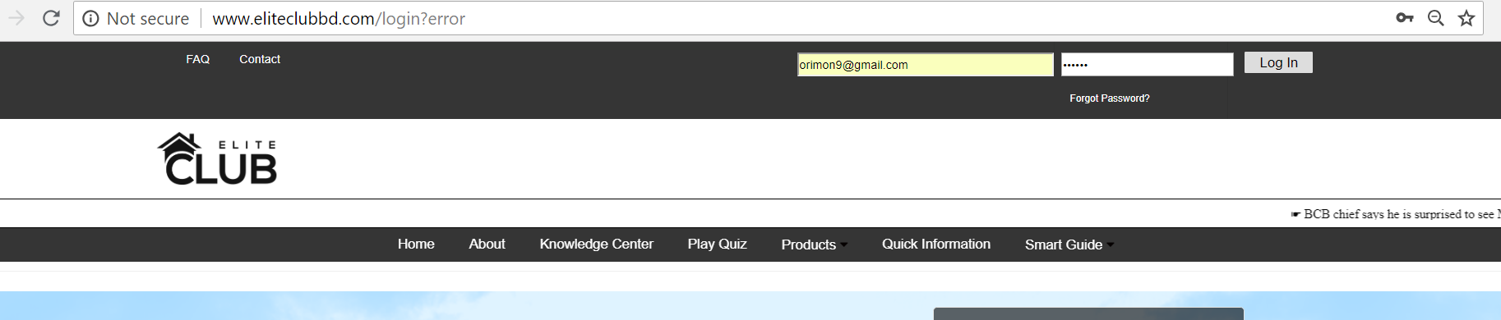

22.**Knowledge center** ->Kids Quiz game -:Quiz gula submit hoi na…??

<http://www.eliteclubbd.com/kidszone.html>

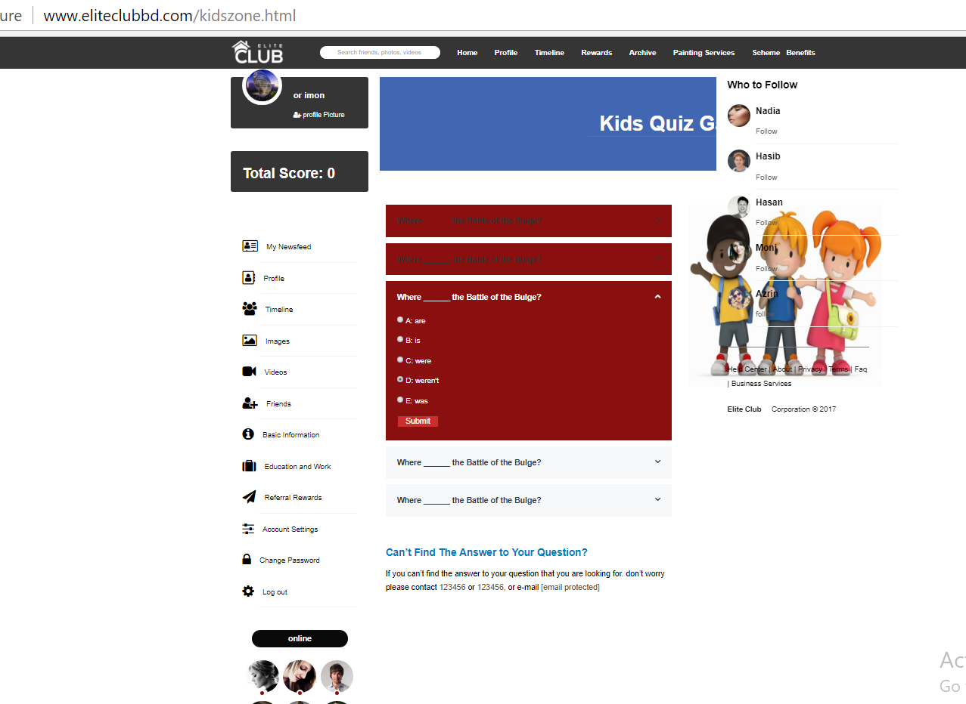

**K**

**ids Quiz Game**